File 8: Economic model 2: Project data (probabilistic sensitivity analysis): Bootstrap scatter plot and Cost effectiveness acceptability curve (control = standard care from Hewett et al 2016)

 | Bootstrap scatter plot | Cost effectiveness acceptability curve
Conf.1 | 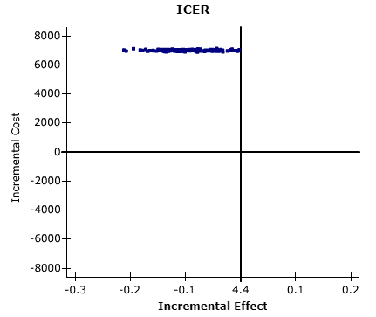 | 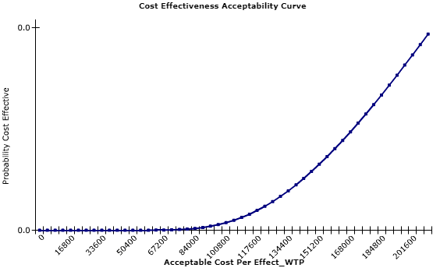
Conf.2 | 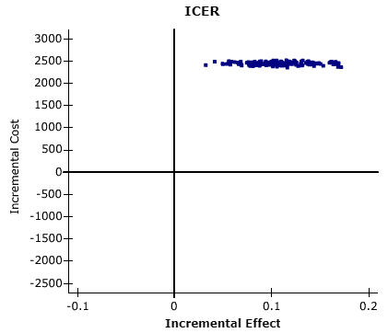 | 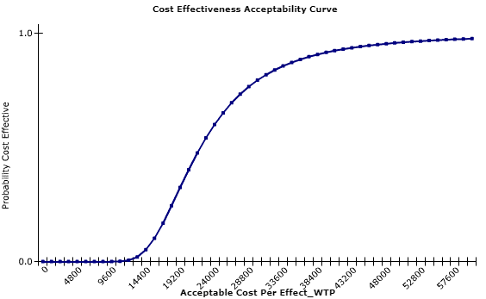
Conf.3 | 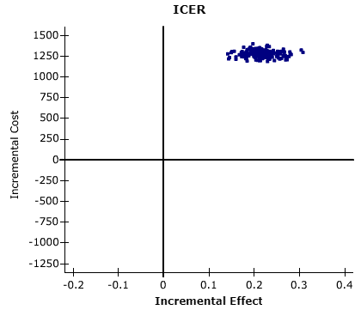 | 