**Report Supplementary Materials 15**

CASE STUDY OF VASCULAR SERVICE RECONFIGURATION- AN ANALYSIS OF HES DATA BETWEEN 2006/07 AND 2017/18 OF YORKSHIRE AND THE HUMBER REGION

1. INTRODUCTION

This study aims to understand the impact of vascular service reconfiguration using analyses from HES data of Yorkshire and Humber region from 2006/07 to 2017/18.

1. OVERVIEW OF AAA SERVICES AND RECONFIGURATIONS IN YORKSHIRE AND THE HUMBER

Yorkshire and the Humber region covers the area shown on the map below (Figure 1). At the beginning of the data (2006/07), there were 12 active sites in the region that provided AAA services. Table 1 presents the number of AAA repairs for each site between 2006/07 and 2017/18.

Figure 1 : Yorkshire and the Humber region

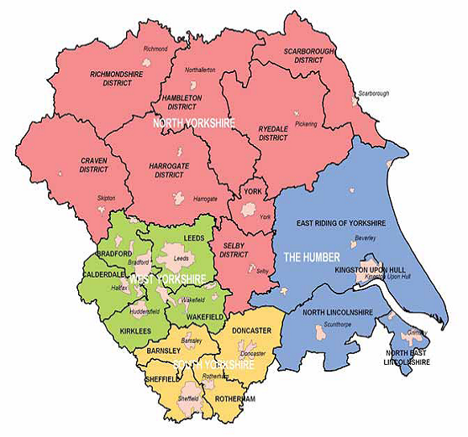

(Source: <https://www.youthworkunit.com/overview-of-the-region/>)

Table 1: Number of AAA repairs by site between 200607 and 201718



As seen in Table 1, the three biggest centres (AAA volume >= 100 cases per year) in the region are Sheffield (Northern General Hospital), Leeds (Leeds General Hospital), and Hull (Hull Royal Hospital). There are two centres with moderate AAA volume (60 =< AAA volume < 100) are York (York Hospital) and Doncaster (Doncaster Royal Infirmary). There are three centres with low-moderate AAA volume (30 <= AAA volume < 60) are Bradford (Bradford Royal Hospital), Huddersfield (Huddersfield Royal Hospital), and Wakefield (Pindersfield Hospital – closed in 201314). The two centres with low AAA volume (10 <= AAA volume < 30) are Harrogate (Harrogate District Hospital – closed in 200708), Scarborough (Scarborough Hospital – closed in 200910), and North East Lincolnshire (Diana Pricess of Wales Hospital – closed in 201112). And the one centre with very low AAA volume (< 10 cases per year) is Airedale (Airedale General Hospital – closed in 201112).

The data showed that there were five reconfigurations (site closure) of AAA services that took place in different years. Table 2 gives a summary of AAA sites in the region and the reconfigurations that were revealed from the data. The first closure was in Harrogate in 200708, the second was in Scarborough in 200910, then two (Airedale and NE Lincolnshire) in 201112 and the final closure was in Wakefield in 201314.

Table 2: Description of AAA sites and reconfigurations in Yorkshire and the Humber

|  |  |  |  |  |  |  |
| --- | --- | --- | --- | --- | --- | --- |
| Screen Area | City | Post Code | Name | Baseline  (200607) | Change | HESyear closed |
| YOH | Hull | HU3 2JZ | Hull Royal | 🗹 | 🗹 | - |
| YOH | York | YO31 8HE | York | 🗹 | 🗹 | - |
| YOH | NE Lincolnshire and Goole | DN33 2BA | Diana, Princess Of Wales (Grimsby) | 🗹 | X | 201112 |
| YOH | Scarborough | YO12 6QL | Scarborough | 🗹 | X | 200910 |
| YOH | Harrogate | HG2 7SX | Harrogate District | 🗹 | X | 200708 |
| CYH | Wakefield | WF1 4DG | Pinderfields | 🗹 | X | 201314 |
| CYH | Leeds | LS1 3EX | L General | 🗹 | 🗹 | - |
| WYO | Bradford | BD9 6RJ | Bradford Royal | 🗹 | 🗹 | - |
| WYO | Airedale | BD20 6TD | Airedale General | 🗹 | X | 201112 |
| WYO | Huddersfield | HD3 3EA | Huddersfield Royal | 🗹 | 🗹 | - |
| SYB | Sheffield | S7 5AU | Northern General | 🗹 | 🗹 | - |
| SYB | Doncaster | DN2 5LT | Doncaster Royal Infirmary | 🗹 | 🗹 | - |

1. IMPACT OF RECONFIGURATION ON WORKLOAD AND PATIENTS’ TRAVEL

This section estimates the impact of reconfiguration on workload and patient travel. There were five closures, which are described below.

* 1. The closure of the Harrogate site HG2 7SX

The Harrogate District Hospital (postcode HG2 7SX) was closed in 200708. In 200607, this hospital still received 11 AAA patients (10 elective, 1 emergency); 10 of them came from the Harrogate district area (1 with missing information). The travel pattern (for AAA repairs) of all patients from the Harrogate district area between 200607 and 201718 was described in Table 3 below.

Table 3: AAA travel pattern for patients from Harrogate district



Initially patients from the Harrogate district went to two hospitals for AAA repairs: the Harrogate site HG2 7SX and the Leeds site LS1 3EX. When the Harrogate site HG2 7SX was closed in 200708, its patients started going to York (YO31 8HE) for their AAA repairs with a peak in the number in 200809 (corresponding to the trend of annual volume of the York site in Table 1).

* 1. The closure of the Scarborough site YO12 6QL

The Scarborough Hospital (postcode YO12 6QL) was closed in 200910. In the years between 200607 and 200809, this hospital still received an average of 17 AAA patients per year. Majority of patients (58%) came from the Scarborough district, 19% from the Ryedale district, 19% from the East Riding of Yorkshire district, 2% from the Wakefield district, and 2% from the Bradford district. Thus, the main catchment area for YO12 6QL includes the Scarborough district, the Ryedale district, and the East Riding of Yorkshire district. The travel pattern (for AAA repairs) of all patients from these three districts between 200607 and 201718 was described in Table 4 below.

Table 4: AAA travel pattern for patients from Scarborough, Ryedale, and East Riding of Yorkshire districts







When the Scarborough site YO12 6QL was closed in 200910, initially its patients started going to Hull (HU3 3JZ) for their AAA repairs (i.e. in 200910 and 201011) but then they started shifting more to York YO31 8HE (from 201112) and towards the end year of the data (201718), it seems that all patients (supposed to belong to YO12 6QL) went to York YO31 8HE.

* 1. The closure of the Airedale site BD20 6TD

The Airedale General Hospital (postcode BD20 6TD) was closed in 201112. In the years between 200607 and 201011, this hospital received an average of 6 AAA patients per year. 41% of patients came from the Bradford district, 34% from the Pendle district, 22% from the Craven district, and 3% from the Burnley district. Thus, the main catchment area of BD20 6TD includes the Bradford district, the Pendle district, and the Craven district. The travel pattern (for AAA repairs) of all patients from these three districts between 200607 and 201718 was described in Table 5 below.

Table 5: AAA travel pattern for patients from Bradford, Pendle, and Craven districts







When the Airedale site BD20 6TD was closed in 201112, its patients from the Bradford district started going to the Huddersfield site HD3 3EA whereas its patients from the Pendle and Craven districts started going to the Bradford site BD9 6RJ.

* 1. The closure of the NE Lincolnshire site DN33 2BA

The Diana Princess of Wales Hospital in North East Lincolnshire (postcode DN33 2BA) was closed in 201213. In the years between 200607 and 201112, this hospital received an average of 23 AAA patients per year. 46% of patients came from the North East Lincolnshire district, 34% from the North Lincolnshire district, 8% from the East Lindsey district, 6% from the West Lindsey district, 3% from the and 3% from the East Riding of Yorkshire district, 1% from the Selby district, and 1% from the York district. Thus, the main catchment area of DN33 2BA includes the North East Lincolnshire district, the North Lincolnshire district, the East Lindsey district, and the West Lindsey district. The travel pattern (for AAA repairs) of all patients from these four districts between 200607 and 201718 was described in Table 6 below.

Table 6: AAA travel pattern for patients from NE Lincoln, North Lincoln, East Lindsey and West Lindsey districts









When the NE Lincolnshire site DN33 2BA was closed in 201112, its patients started going to the Hull site HY3 2JZ.

* 1. The closure of the Wakefield site WF1 4DG

The Pinderfields Hospital in Wakefield (postcode WF1 4DG) was closed in 201314. In the years between 200607 and 201213, this hospital received an average of 47 AAA patients per year. 64% of patients came from the Wakefield district, 23% from the Kirklees district, 9% from the Leeds district, 2% from the Selby district, 1% from Barnsley, East Riding of Yorkshire and Harrogate districts. Thus, the main catchment area of WF1 4DG includes the Wakefield district, the Kirklees district, the Leeds district. The travel pattern (for AAA repairs) of all patients from these three districts between 200607 and 201718 was described in Table 7 below.

Table 7: AAA travel pattern for patients from Wakefield, Kirklees, and Leeds districts







When the Wakefield site WF1 4DG was closed in 201314, its patients started going to the Leeds site LS1 3EX.

1. IMPACT OF RECONFIGURATION ON OUTCOMES

Based on the investigation described in section 4, four groups of vascular sites that that were directly affected by the service reconfigurations in the region were identified:

* Group 1: York Hospital (YO31 8HE), Harrogate District Hospital (HG2 7SX), and Scarborough Hospital. This group was identified from the investigation on the closure of Harrogate District Hospital in 200708 and the closure of Scarborough hospital in 200910. In both reconfigurations, the York Hospital was directly affected by picking up cases from those two closed sites.
* Group 2: Huddersfield Royal Hospital (HD3 3EA), Bradford Royal Hospital (BD9 6RJ), and Airedale General Hospital (BD20 6TD). This group was identified from the investigation on the closure of AAA services at the Airedale General Hospital in 201112. Both Huddersfield Royal Hospital and Bradford Royal Hospital were directly affected by this closure since they picked up cases from the closed site.
* Group 3: Hull Royal Hospital (HU 3 2JZ) and Diana Princess of Wales Hospital in NE Lincolnshire (DN33 2BA). This group was identified from the investigation on the closure of AAA services at the NE Lincolnshire site in 201112. The vascular site at Hull was directly affected by picking up cases from the closed site.
* Group 4: The Leeds General Hospital (LS1 3EX) and the Pinderfields Hospital in Wakefield (WF1 4DG). This group was identified from the investigation on the closure of AAA services at the Wakefield site in 201314. The vascular site at Leeds was directly affected by picking up cases from the closed site.
  1. Group 1: AAA services of York, Harrogate, and Scarborough sites

A summary of the in-hospital outcomes for each hospital across the years is presented in Table 8.

Table 8: Summary of outcomes for AAA services of York, Harrogate and Scarborough sites





When the AAA service at the Harrogate site HG2 7SX was closed, its patients started going to the York site YO31 8HE for AAA repairs from 200708. The elective in-hospital mortality and averaged length of stay for HG2 7SX in 200607 were 20% and 14 days respectively; and for YO31 8HE were 16.2% and 14 days respectively. There was only one emergency case observed in 200607 for HG2 7SX. After the closure of the Harrogate site, its immediate effect on in-hospital outcomes can be seen with the outcomes of YO31 8HE: 8.8% elective in-hospital mortality and 10 days for averaged elective length of stay. Similarly we can see the effects of closing the Scarborough site YO12 6QL in 200910 on in-hospital outcomes by comparing the summary information of YO12 6QL and YO31 8HE before 200910 and after 200910.

To investigate the impacts of service configuration on long-term survival, survival analysis was performed. Figures 2-4 present the results of these survival analysis of HES data. However, it should be noted that there are many factors involved in explaining the differences in the outcomes between centres and between different years. First, there are differences in the characteristics of the patients cohorts between different centres and different years. Second, there are differences in the characteristics of different centres where patients were treated. Even with the same centre, its characteristics change moving from one year to another due to changes in practice, staff, etc. Third, there are also other changes in the region that could influence outcomes besides service reconfiguration (i.e. the implementation of a screening programme, public health activities, etc.). Thus, we cannot attribute the observed change in outcomes to service reconfiguration alone.

Figure 2: 200607 cohort of post-discharge survivors

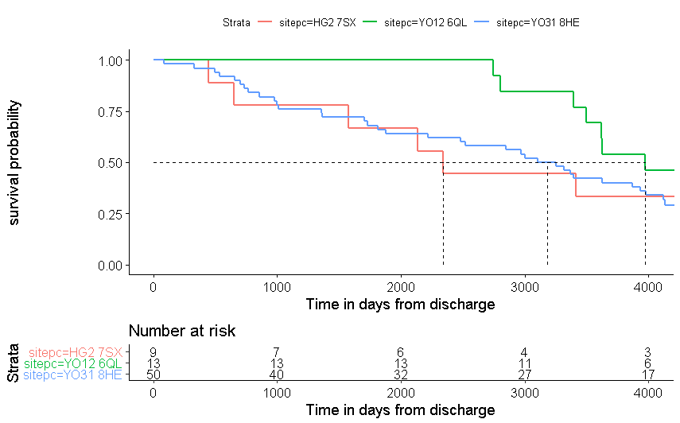

Figure 3: cohort 200708 to 200910

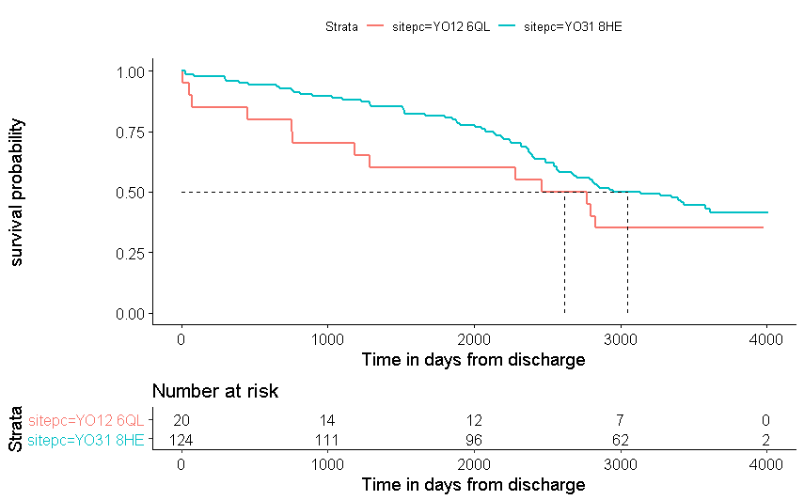

Figure 4: York site by yeargroup

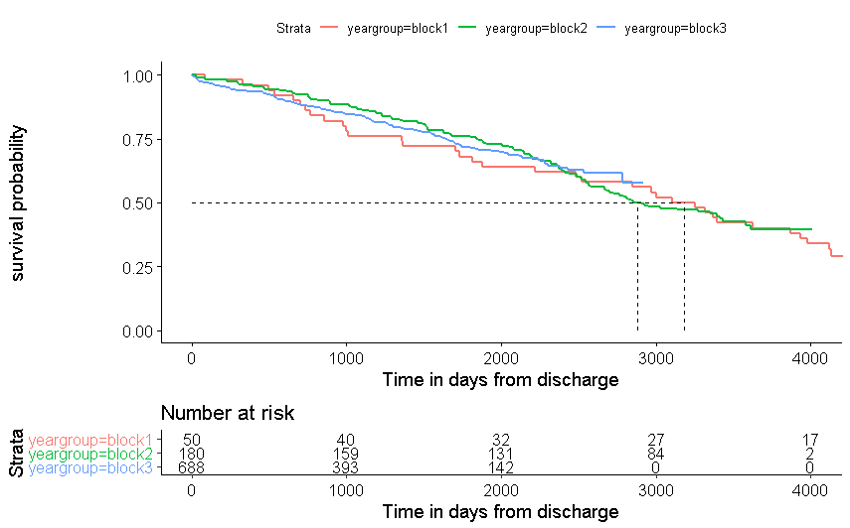

Yeargroup – block 1: 200607; Yeargroup – block 2: 200708 to 200910 ; Yeargroup – block 3: 201011 to 201718

* 1. Group 2: AAA services of Airedale, Huddersfield and Bradford sites

A summary of the outcomes for each hospital across the years is presented in Table 9

Table 9: Summary of outcomes for AAA services of Airedale, Huddersfield and Braford sites





* 1. Group 3: AAA services of Hull and NE Lincolnshire sites

A summary of the outcomes for each hospital across the years is presented in Table 10

Table 10: Summary of outcomes for AAA services of Hull and NE Lincolnshire sites





* 1. Group 4: AAA services in Wakefield and Leeds

A summary of the outcomes for each hospital across the years is presented in Table 11.

Table 11: Summary of outcomes for AAA services of Leeds and Wakefield sites





1. IMPACT OF RECONFIGURATION ON PATIENT TRAVEL

One of the main assumptions in the cost-effectiveness simulation is that patients always go to their nearest available vascular site for vascular repairs. This assumption is tested with the case study of Yorkshire and the Humber as follows.

First, the data for Yorkshire and the Humber cohort was divided into five groups by hesyear. The first group includes patients in the year 200607. That was when all 12 sites in the region were still active. The second group includes patients in the years between 200708 and 200809. That was after the closure of the Harrogate site and before the closure of the Scarborough site, thus there were 11 active sites in the region. The third group includes patients in the years between 200910 and 201011. That was after the closure of the Scarborough site and before the closure of the Airedale and the NE Lincolnshire sites, thus there were 10 active sites in the region. The fourth group includes patients in the years between 201112 and 201314. That was after the closure of the Airedale and NE Lincolnshire sites and before the closure of the Wakefield site, thus there were 8 active sites in the region. The fifth group includes patients in the years between 201415 and 201718. That was after the closure of the Wakefield site, thus there were 7 active sites in the region.

This is illustrated in Table 12.

Table 12: Active sites in Yorkshire and the Humber by years

|  |  |  |  |  |  |  |
| --- | --- | --- | --- | --- | --- | --- |
| City | Post Code | 200607 | 200708 – 200809 | 200910 - 201011 | 201112 – 201314 | 201415 - 201718 |
| Hull | HU3 2JZ | 🗹 | 🗹 | 🗹 | 🗹 | 🗹 |
| York | YO31 8HE | 🗹 | 🗹 | 🗹 | 🗹 | 🗹 |
| NE Lincolnshire | DN33 2BA | 🗹 | 🗹 | 🗹 | X | X |
| Scarborough | YO12 6QL | 🗹 | 🗹 | X | X | X |
| Harrogate | HG2 7SX | 🗹 | X | X | X | X |
| Wakefield | WF1 4DG | 🗹 | 🗹 | 🗹 | 🗹 | X |
| Leeds | LS1 3EX | 🗹 | 🗹 | 🗹 | 🗹 | 🗹 |
| Bradford | BD9 6RJ | 🗹 | 🗹 | 🗹 | 🗹 | 🗹 |
| Airedale | BD20 6TD | 🗹 | 🗹 | 🗹 | X | X |
| Huddersfield | HD3 3EA | 🗹 | 🗹 | 🗹 | 🗹 | 🗹 |
| Sheffield | S7 5AU | 🗹 | 🗹 | 🗹 | 🗹 | 🗹 |
| Doncaster | DN2 5LT | 🗹 | 🗹 | 🗹 | 🗹 | 🗹 |
| Total active sites | | 12 | 11 | 10 | 8 | 7 |

Second, for each of the five data periods, patients were re-assigned to their nearest available vascular centre in Yorkshire and the Humber region. This was done based on the straight-line distance between patient location (by LSOA) and the locations of available sites. After that, the site assigned based on nearest distance was compared with the site that patients actually went to. The results are reported in Table 13 below.

Table 13: Proportion of patients went to their nearest site

|  |  |  |  |  |
| --- | --- | --- | --- | --- |
| Data period | % went to nearest site | | Additional distance if not going to the nearest (miles) | |
| Within region | Include out-region | Median | Mean |
| 200607 | 76.54% | 79.25% | 4.1 | 11.4 |
| 200708 - 200809 | 73.4% | 75.2% | 4.7 | 10.8 |
| 200910 - 201011 | 71.7% | 75.4% | 4.2 | 13.2 |
| 201112 – 201314 | 73.4% | 76.2% | 4.2 | 12.1 |
| 201415 - 201718 | 76.4% | 80.1% | 4.9 | 14.4 |

Majority of patients went to the nearest site for their vascular repairs (more than 70% and up o 80%).

1. IMPACT OF RECONFIGURATION ON THE PROPORTION OF PATIENTS RECEIVING EVAR

Another main assumption in the base-case for the cost-effectiveness simulation is that reconfiguration of services does not affect the treatment decision between EVAR and open repairs. To test this assumption with the case study of Yorkshire and the Humber, the proportion of EVAR in the region was summarised and compared between different years to see the changes in proportion of EVAR before and after the year of reconfiguration. The results are presented in Table 14.

Table 14: proportion of evar for Yorkshire and the Humber region by years

|  |  |  |  |
| --- | --- | --- | --- |
|  | Yorkshire and the Humber region | | |
| hesyear | **n_case** | **n_evar** | **%evar** |
| 200607 | 665 | 27 | 4% |
| 200708 | 704 | 119 | 17% |
| 200809 | 694 | 188 | 27% |
| 200910 | 637 | 196 | 31% |
| 201011 | 630 | 238 | 38% |
| 201112 | 671 | 286 | 43% |
| 201213 | 612 | 262 | 43% |
| 201314 | 684 | 294 | 43% |
| 201415 | 678 | 318 | 47% |
| 201516 | 659 | 334 | 51% |
| 201617 | 608 | 315 | 52% |
| 201718 | 602 | 315 | 52% |

There was a general increasing trend of the proportion of EVAR in the region between 200607 and 201718 (from 4% in 200607 to 52% in 201718). However, it seems that this increasing trend is more likely due to changes in practice rather than an effect of service reconfigurations. For example, the proportion of EVAR remains the same between 201112 and 201314 despite the closure of the Airedale, NE Lincolnshire and Wakefield sites.

1. CONCLUSIONS

From the HES data analysis, we could accurately identify when and where service reconfiguration took place (which site was closed and where its patients went to after the closure) and what was the impact on workload and patient travel patterns.

It was observed that the patients often go to their nearest available site; and that service reconfiguration does not seem to increase the proportion of EVAR repair.

However, it is difficult to attribute the impacts of service reconfiguration on other outcomes including in-hospital outcomes and long-term survival. This is because the observed changes with outcomes could be explained by the complicated interaction of several factors besides service reconfiguration.