

File 7. Example of feedback to care home
Feedback for [CH name] from the REACH research team

Evidence suggests that moving round more and reducing sedentary time, i.e. sitting fairly still for long periods, has beneficial effects on the health and well-being of care home residents. What we don’t know much about is the proportion of time residents typically spend sitting and moving as part of their daily routines.
What we set out to do
We decided to find out more about levels of movement by working closely with four residential care homes in West Yorkshire. These homes ranged in size from 28 to 96 beds. Two approaches to generate data were used. Firstly, researchers spent time in the care homes undertaking observations. This involved watching what residents did and talking to them about movement. Secondly, residents in the homes were invited to wear an activity monitor during day time hours over the course of a week which allowed us to record how much time they spent sitting and moving.
Because the amount that an individual moves is thought to influence their well-being we were interested in trying out some questionnaires designed to assess this. We hoped that this would provide feedback on the format and the suitability of questions asked as well as indicating levels of residents’ well-being.
Finally, we wanted to work together with care home residents, staff and relatives to develop “Action Groups” in order to identify ways of promoting movement amongst residents which would be sustainable over the longer term.
What we have found
Seventeen observation visits took place at [CH name] between February and August of 2015 with researchers spending time on all three floors.
Levels of movement
As a result of our observations we were able to gain an understanding of:
- Staff and residents’ perceptions of typical levels of movement and time spent sedentary.
- The routines within the care home and the impact this had on levels of movement and sedentary time.
- Staff roles and perception of enabling movement as part of this.
- How residents and staff interacted with each other and the impact this had on levels of movement and sedentary time.
- Whether any attempts to increase the amount that residents moved were effective.
38 residents across the 4 homes wore the activity monitor long enough to provide data. 25 of these individuals lived in [CH name] and residents from all three floors wore monitors.
As a result of the activity monitor data we were able to find out about how much time specific residents spent either sedentary or moving. The chart below shows the average time that these residents spent moving each day.
Average percentage of recorded time either sedentary or moving
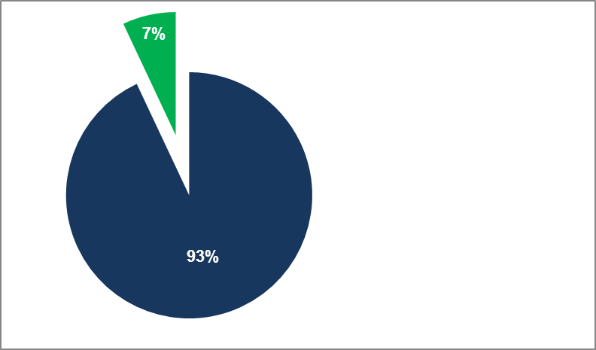
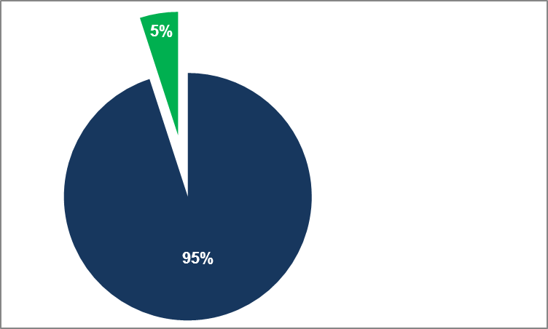
Average across all 4 care homes
Movement
[standing up from chair, walking, self-care activities]
Sedentary
[sitting, lying, limited movement]
Average at [CH name]

Our main findings from the monitors were that ……..
Residents across all 4 care homes spent the vast bulk of their time sitting or lying, and moving very little.

There was no difference in the amount of recorded movement between days of the week.

When comparing data from [CH name] with combined data from all four care homes we noted that…
Residents wearing monitors recorded slightly more average movement than those across all four care homes.

It is recognised from observations and conversations that there is a group of residents at [CH name] that are much more physically active than these figures suggest. Some of these spend a great deal of time on their feet and are at risk of too much activity.
Differences in recorded movement through the day
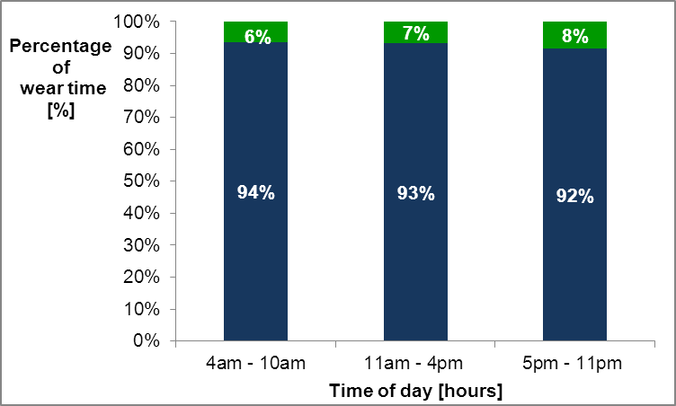
Sedentary
Movement
Average across all four care homes

We compared data from different times during the day and found that there was a slight increase in recorded activity levels as the day progressed – this pattern was seen when looking at the data across the 4 care homes

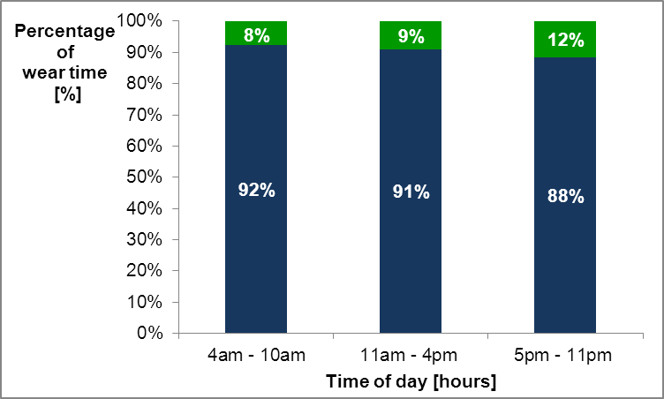
Increased movement through the day was particularly noticeable in the monitor data from [CH name]. This was also clear from our observations; several residents on both Iverson and Grange 2 became increasingly restless as the afternoons progressed.
Average at [CH name]

Differences in residents’ movement between units at [CH name]
At [CH name] we were able to compare the amount of recorded movement between the three floors and found that residents wearing monitors on Iverson and Grange moved more than those residents on Court
Based on our observations, we felt that whilst agitation and restlessness may explain the higher levels of movement on Iverson and Grange, the homely atmosphere on Grange also helped to promote engagement in activities that involved movement.
Average at [CH name]
Patterns of movement
Activity monitors allowed us to look in detail at how individuals moved throughout the course of a day. The graph below represents the pattern of movement recorded by one of the care home residents during a single day.
We found that the residents wearing monitors did not move very much and when they did move it tended to be in short bursts. This is highlighted by the graph below.
Activity monitor counts per minute [cpm]
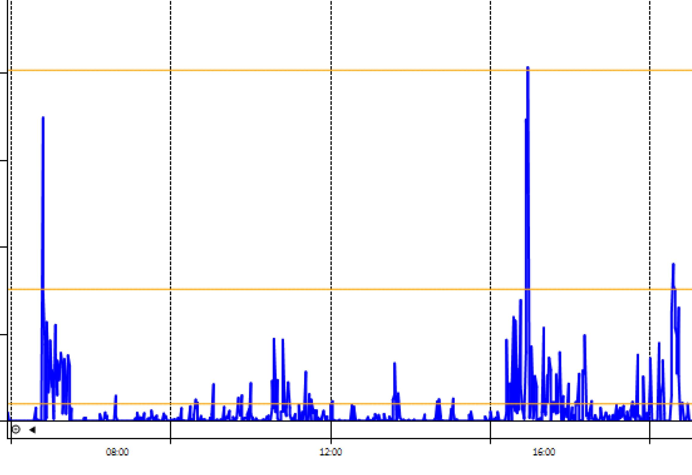
The main form of regular movement observed in all the care homes generally involved accessing the toilet or moving to a different location for meals / organised activities.

Our observations suggest that if some of the more active residents at [CH name] had worn a monitor their graph would have looked quite different from this.
7am 8am 9am 10am 11am 12pm 1pm 2pm 3pm 4pm 5pm 6pm
Moderate
Light
Low
Sedentary
Time of day [hours]
Monitor put on
Monitor taken off
This period of moderate activity was
Less than 5 minutes
Promoting movement in the care home environment
Based on our observations, conversations and Action Groups in the four care homes, making changes to encourage residents to move more is difficult. We identified a number of barriers…..

At [CH name], responsibility to take the physical activity agenda forwards was largely the responsibility of activity coordinators and not shared by other staff.

Barriers to movement: our findings from across the four care homes
Residents’ physical frailty.
Residents choosing to remain in their rooms which reduced the opportunity to interact with others.
Lack of opportunities to access the outdoor environment.
Staff were not always aware of the benefits of movement.
Inflexible care home routines.
Putting time aside to try out ideas to promote movement was difficult given the high staff workloads.
Sometimes there appeared to be a lack of “buy- in” from staff regarding the ideas that were being tested.
Encouraging residents to move more was often not deemed a priority.
Staff focusing on care tasks rather than movement.
Limited ownership of promoting change amongst the staff.

At [CH name] “ownership” of encouraging more movement amongst the staff group was sometimes limited.

But increasing the amount that residents move can be done and can result in clear benefits!
At [CH name], staff, relatives and residents were able to identify ways which movement might be encouraged.
Staff, relatives and residents were initially enthusiastic about the [CH name] Action Groups.
Facilitators to movement: our findings from across the four care homes
“Larking around” such as impromptu dancing by care staff was seen to have a positive effect on the amount of movement performed by residents.
Playing music resulted in increased movement [for example foot tapping / clapping] being seen.
Enabling residents to move to different rooms.
Enabling residents to go outdoors.
Enabling residents to take on ‘roles’ within the care home.
A number of ideas for encouraging residents to move more were trialled.
Organised activities.
1 to 1 interactions.

Residents at [CH name] were observed collecting crockery and returning it to the kitchens.

Oomph sessions at [CH name] were highly effective in promoting movement for a number of residents and their enjoyment of these sessions was clear during observations.
What we learned trying out a range of health and well-being questionnaires at [CH name]
We set out to try seven different health and well-being questionnaires in the care homes. 10 residents at [CH name] completed 29 of these questionnaires. Residents reported low levels of depression and mostly rated their quality of life positively despite acknowledging poor physical health. Trying out these measures provided insight into the suitability of the questions being asked and offered feedback on the format of the questionnaire itself. We found that some of the questionnaires did not work well in the care home setting. Others were effective in getting residents to talk about their health and reflect on their sense of well-being. Their feedback has helped us to identify which questionnaires would be most appropriate to use in the future.

What we found when we used monitors again at the end of the research period
Residents who wore the activity monitor at the beginning of the project were invited to wear it again at the end, approximately 4 months later. 25 residents across the 4 care homes wore the activity monitor long enough at both time points to give us an idea of what they typically do.
Average movement at the beginning and end of the research period
The level of movement actually decreased at the second measurement point.

It is unclear from observations why this change happened at [CH name].

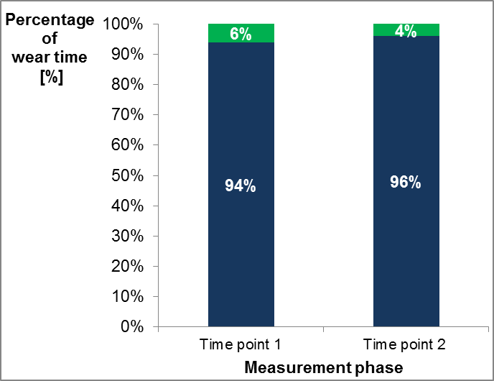
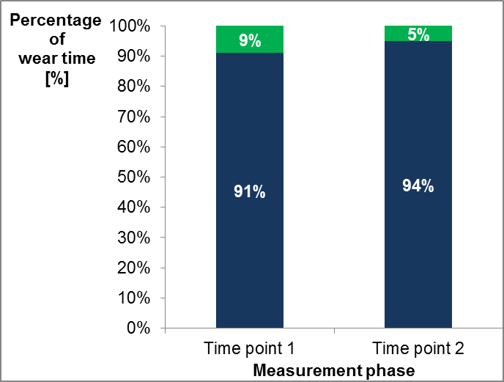
Average across all 4 homes [n= 25]
Average at [CH name] [n = 18]

Sedentary
Movement
It is possible that this change at [CH name] reflects staff turnover. Key members of staff such as the activity coordinator left their posts during this time.

Moving forward…

This work has helped us gain an understanding of the following:
- The amount of time residents in a care home environment typically spend both sitting and moving about.
- The potential barriers and facilitators to movement in a care home environment.
- Potential ways of encouraging residents to move more and how these may become sustainable over the long term.

Working with you has helped us to develop materials which we feel will help support care homes to encourage residents to move more. We now have valuable data which we can use in the next phase of our research in care homes.

If you would like to receive further information about our findings please contact either of the following at the Bradford Institute for Health Research:
- Professor Anne Forster, xxx, email: xxx
- Jennifer Airlie, xxx, email: xxx

Thank you

We are very grateful to all staff, residents and relatives within the four care homes for their support and interest in our work.

Research funded by the National Institute for Health Research (NIHR)

Disclaimer
This report presents independent research funded by the National Institute for Health Research (NIHR) under the Programme Grants for Applied Research programme RP-PG-1210-12017. The views expressed are those of the author(s) and not necessarily those of the NHS, the NIHR or the Department of Health.

